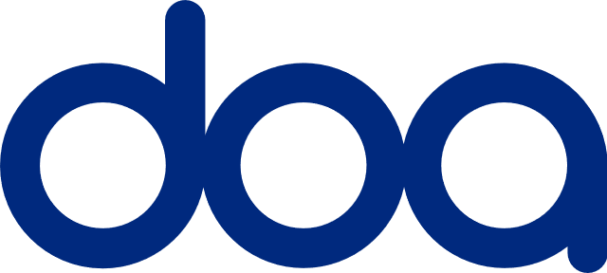

Professional Risks

Asbestos Proposal Form

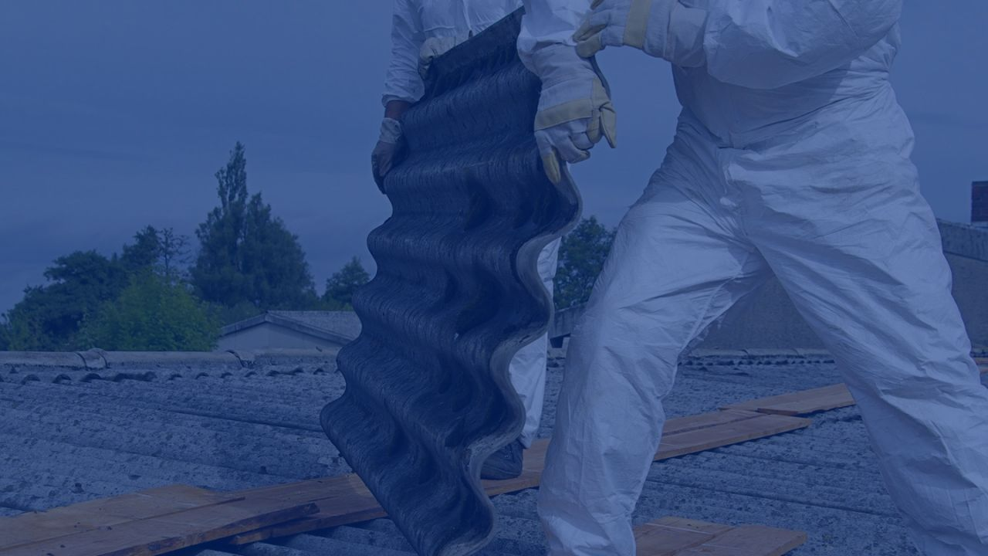

DOA takes your privacy very seriously. We collect and process information about you in order to provide insurance policies and to process claims. Your information is also used for business purposes such as fraud prevention and financial management. This may involve sharing or obtaining information about you within our group of companies and other third parties such as insurers, sub brokers, loss adjusters, credit reference agencies, service providers, professional advisors, our regulators and fraud prevention agencies. We may record telephone calls to help us monitor and improve the service we provide. For further information on how your information is used and your rights in relation to your information please see our [Privacy Policy](https://www.doainsurance.co.uk/privacy-policy/). If you do not have access to the internet please contact us and we will send you a printed copy.

DOA Underwriting Ltd is an independent underwriting agency, wholesale broker and principal company for David Oliver T/as David Oliver Associates and DOA Special Facilities Ltd (DOA) and is Authorised and Regulated by the Financial Conduct Authority, FRN 772309.